The Future of Nursing 2020-2030: Charting a Path to Achieve Health Equity (2021)

Copyright National Academy of Sciences. All rights reserved
209 THE FUTURE OF NURSING 2020–2030

Continually Adapting to New Technologies
Nurses can use a wide variety of existing and emerging technologies and tools to address SDOH and provide high-quality care to all patients (see Box 7-5). Broadly speaking, these technologies and tools fall into three categories: patient-facing, clinician-facing, and data analytics. Patient- and clinician-facing tools collect data and help providers and patients connect and make decisions
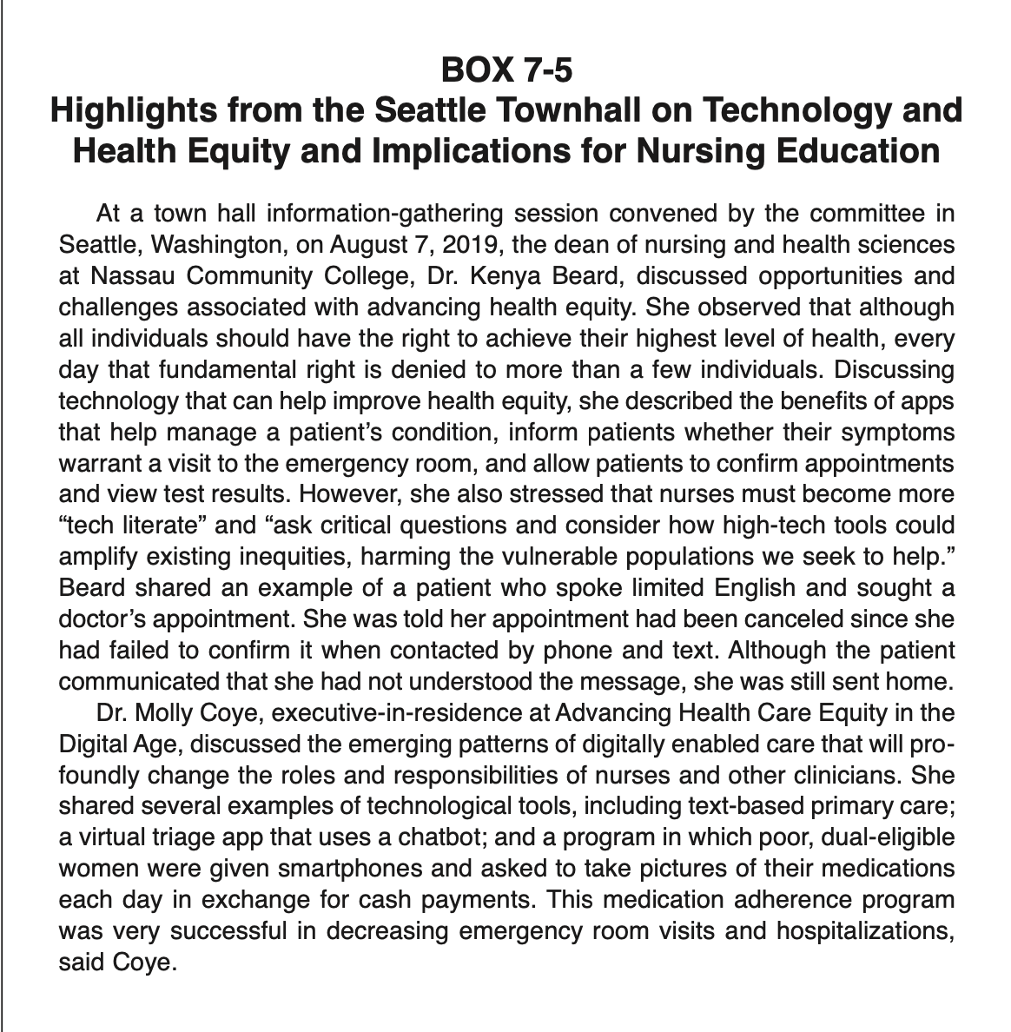
210 THE FUTURE OF NURSING 2020–2030
about care. Data analytics uses data, collected from patients or other sources, to analyze trends, identify disparities, and guide policy decisions. Beginning as students, all nurses need to be familiar with these technologies, be able to engage with patients or other professionals around their appropriate use, and understand how their use has the potential to exacerbate inequalities.
Patient-facing technologies include apps and software, such as mobile and wearable health devices, as well as telehealth and virtual visit technologies (FDA, 2020). These tools allow nurses and other health care providers to expand their reach to those who might otherwise not have access because of geography, transportation, social support, or other challenges. For example, telehealth and mobile apps allow providers to see people in their homes, mitigating such barriers to care as transportation while also helping providers understand people in the context of their everyday lives. Essential skills for nurses using these new tools will include
211 THE FUTURE OF NURSING 2020–2030
the ability to project a caring relationship through technology (Massachusetts Department of Higher Nursing Education Initiative, 2016) and to use technology to personalize care based on patient preferences, technology access, and individ- ual needs (NLN, 2015b). The role of telehealth and the importance of training nurses in this technology have been recognized for several years (NONPF, 2018; Rutledge et al., 2017), but the urgent need for telehealth services during the COVID-19 pandemic has made it “imperative” to include telehealth training in nursing curricula (Love and Carrington, 2020). Moreover, it is anticipated that the shift to telehealth for some types of care will become a permanent feature of the health care system in the future (Bestsennyy et al., 2020).
Clinician-facing technologies include EHRs, clinical decision support tools, mobile apps, and screening and referral tools (Bresnick, 2017; CDC, 2018; Heath, 2019). A number of available digital technologies can facilitate the collection and integration of data on social needs and SDOH and help clinicians hold compassionate and empathetic conversations about those needs (AHA, 2019; Giovenco and Spillane, 2019). In 2019, for example, Kaiser Permanente launched its Thrive Local network (Kaiser Permanente, 2019), which can be used to screen for social needs and connect people with community resources that can meet these needs. The system is integrated with the EHR, and it is capable of tracking referrals and outcomes to measure whether needs are being met; these data can then be used to continuously improve the network.
Nurses will need to understand how and when to use these types of tools, and can leverage their unique understanding of patient and community needs to improve and expand them. As described in Chapter 10, such technologies as EHRs and clinical alarms can burden nurses and contribute to workplace stress. However, nurses have largely been left out of conversations about how to design and use these systems. For example, although nurses are one of the primary users of EHR systems, little research has been conducted to understand their experiences with and perceptions of these systems, which may be different from those of other health care professionals (Cho et al., 2016; Higgins et al., 2017). Out of 346 usability studies on health care technologies conducted between 2003 and 2009, only 2 examined use by nurses (Yen and Bakken, 2012). Educating nurses to understand and assess the benefits and drawbacks of health care technologies and have the capacity to help shape and revamp them can ultimately improve patient care and the well-being of health professionals.
Tools for data analytics are increasingly important for improving patient care and the health of populations (Ibrahim et al., 2020; NEJM Catalyst, 2018). Analysis of large amounts of data from such sources as EHRs, wearable monitors, and surveys can help in detecting and tracking disease trends, identifying disparities, and finding patterns of correlation (Breen et al., 2019; NASEM, 2016a; Shiffrin, 2016). The North Carolina Institute for Public Health, for example, collaborated with a local health system in analyzing data to inform a community health improvement plan (Wallace et al., 2019). Data on 12 SDOH indicators were sourced
212 THE FUTURE OF NURSING 2020–2030
from the American Community Survey and mapped by census tract. The mapping provided a visualization of the disparities in the community and allowed the health system to focus its efforts strategically to improve community health. The North Carolina Department of Health and Human Services later replicated this strategy across the entire state (NCDHHS, 2020).
There are opportunities for nurses to specialize in this type of work. For example, nursing informatics is a specialized area of practice in which nurses with expertise in such disciplines as information science, management, and analytical sciences use their skills to assess patient care and organizational procedures and identify ways to improve the quality and efficiency of care. In the context of SDOH, nursing informaticists will be needed to leverage artificial intelligence and advanced visualization methods to summarize and contextualize SDOH data in a way that provides actionable insights while also eliminating bias and not overwhelming nurses with extraneous information. Big data are increasingly prevalent in health care, and nurses need the skills and competencies to capitalize on its potential (Topaz and Pruinelli, 2017). Even nurses who do not specialize in informatics will need to understand how the analysis of massive datasets can impact health (Forman et al., 2020; NLN, 2015b). Investments in expanding program offerings, certifications, and student enrollment will be needed to meet the demand for nurses with such skills.
As noted, however, despite its promise for improving patient care and community health, technology can also exacerbate existing disparities (Ibrahim et al., 2020). For example, people who lack access to broadband Internet and/or devices are unable to take advantage of such technologies as remote monitoring and telehealth appointments (Wise, 2012). Older adults, people with limited formal education, those living in rural and remote areas, and the poor are less likely to have access to the Internet. As health care becomes more reliant on technology, these groups are likely to fall behind (Arcaya and Figueroa, 2017). In addition, such technologies as artificial intelligence and algorithmic decision-making tools may exacerbate inequities by reflecting existing biases (Ibrahim et al., 2020). Nursing education needs to prepare nurses to understand these potential down- sides of technology in order to prevent and mitigate them. This has become a particularly critical issue during the COVID-19 pandemic, with the rapid shift to telehealth potentially having consequences for those with low digital literacy, limited English proficiency, and a lack of access to the Internet (Velasquez and Mehrotra, 2020).
Not all nurses will need to acquire all of the key technological competencies; curricula can be developed according to the likely needs of nurses working at different levels. For example, most nurses will need the knowledge and skills to use telehealth, digital health tools, and data-driven clinical decision-making skills in practice, whereas nurse informaticians and some doctoral-level nurses will need to be versed in device design, bias assessment in algorithms, and big data analysis.

