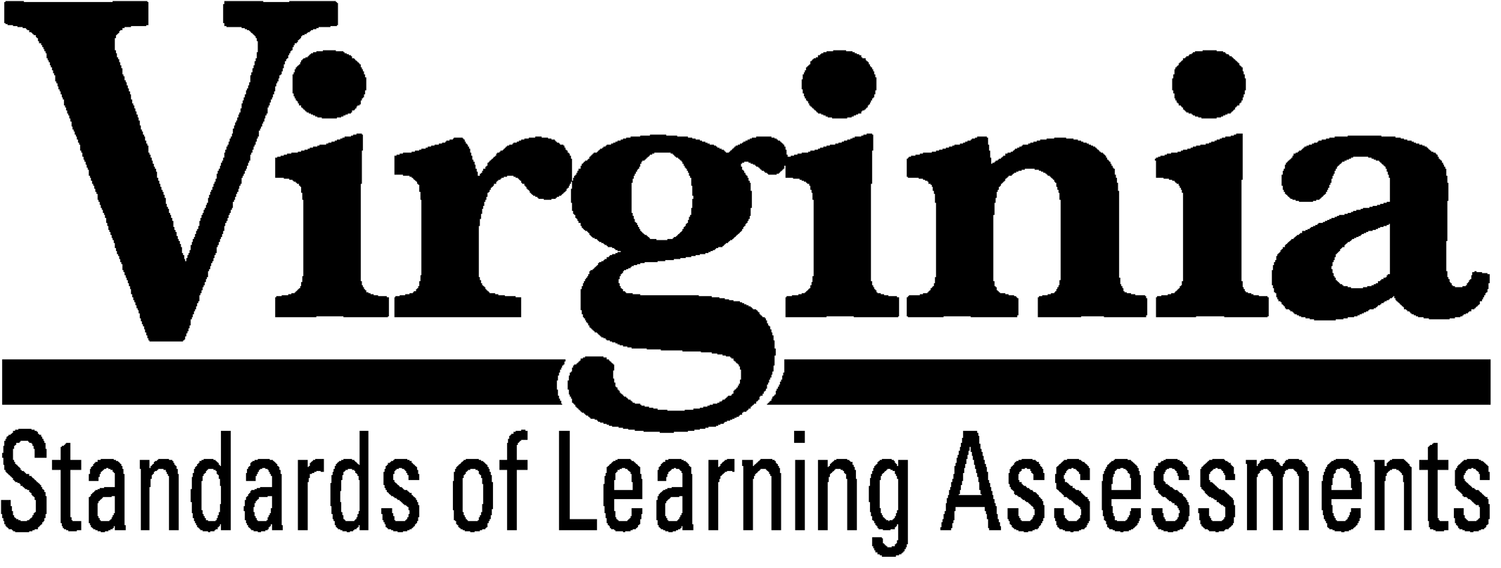

Test Blueprint
Grade 4 Mathematics
2016 Mathematics
Standards of Learning
This test blueprint will be effective with the administration of the spring 2023 Mathematics Standards of Learning (SOL) tests.

Notice to Reader
In accordance with the requirements of the Civil Rights Act and other federal and state laws and regulations, this document has been reviewed to ensure that it does not reflect stereotypes based on race, color, national origin, sex, age, or disability.

The Virginia Department of Education does not discriminate on the basis of race, sex, color, national origin, religion, sexual orientation, gender identity, age, political affiliation, or against otherwise qualified persons with disabilities in employment or provisions of service.
Copyright ©2023 by the Commonwealth of Virginia, Department of Education, P.O. Box 2120, Richmond, Virginia 23218-2120. All rights reserved. Except as permitted by law, this material may not be reproduced or used in any form or by any means, electronic or mechanical, including photocopying or recording, or by any information storage or retrieval system, without written permission from the copyright owner. Commonwealth of Virginia public school educators may reproduce any portion of this test blueprint for noncommercial educational purposes without requesting permission. All others should direct their written requests to the Virginia Department of Education at the above address or by email to Student_Assessment@doe.virginia.gov.

Grade 4 Mathematics
Standards of Learning

Test Blueprint

TABLE OF CONTENTS

General Test Information………………………………………………………..1
Defines common terms

Test Blueprint Summary Table………………………………………………….3
Organizes the SOL and the number of items assessed

Expanded Test Blueprint……...…………………………………………………4
Full text of each SOL as organized for the test

General Test Information

Test Blueprint
Much like the blueprint for a building, a test blueprint serves as a guide for test construction. The blueprint indicates the content areas that will be addressed by the test and the number of items that will be included by content area and for the test as a whole. There is a blueprint for each test (e.g., grade 3 reading, grade 5 mathematics, grade 8 science, Virginia and United States History).

The Grade 4 Mathematics blueprint contains information for two types of tests, the online computer adaptive test (CAT) and the traditional test. A CAT is an online assessment that is customized for every student based on how the student responds to the questions. This is in contrast to the traditional test in which all students who take a particular version (paper, large print, or braille) of the test respond to the same test questions. All online versions of the Grade 4 Mathematics Standards of Learning (SOL) test (including audio) are computer adaptive.

All students are required to take the online version of the SOL tests with the exception of students who meet the criteria for needing a paper test. All paper versions of the test (including large print and braille) will be administered using the traditional format. All test questions for Grade 4 Mathematics have been determined to meet the criteria for Universal Design. The Universal Design principles require that language that is not specific to the content area (e.g., mathematics) be simplified and test questions be written so they are accessible by all populations of students. The SOL test questions have been reviewed by Virginia teachers and have been determined to meet the criteria for Universal Design.

Reporting Categories
Each test covers a number of Standards of Learning. In the test blueprint, the SOL are grouped into categories that address related content and skills. These categories are labeled as reporting categories. For example, a reporting category for the Grade 4 Mathematics Standards of Learning test is Computation and Estimation. Each of the SOL in this reporting category addresses computation using addition, subtraction, multiplication, or division or requires the student to estimate the answer to a problem. When the results of the SOL tests are reported, the scores will be presented for each reporting category and as a total test score.

Assignment of Standards of Learning to Reporting Category
In the Grade 4 Mathematics SOL test, each SOL is assigned to only one reporting category. For example, SOL 4.1a-c is assigned to “Number and Number Sense.”

Coverage of Standards of Learning
Due to the large number of SOL in each grade level content area, every Standard of Learning will not be assessed on every SOL test. By necessity, to keep the length of a test reasonable, each test will sample from the SOL within a reporting category. All SOL are eligible for inclusion on the traditional forms as well as the CAT forms.

Use of the Curriculum Framework
The Grade 4 Mathematics Standards of Learning, amplified by the Curriculum Framework, define the essential understandings, knowledge, and skills that are measured by the Standards of Learning tests. The Curriculum Framework asks essential questions, identifies essential understandings, defines essential content knowledge, and describes essential skills students need to master.

Use of Calculators
Grade 4 SOL calculator-active items will have the online calculator included with the item on the toolbar. For additional information, please refer to the list of Online Mathematics Tools available on the Grades 3-8 Mathematics Growth Assessments.

Additional Items
Beginning in spring 2023, the computer adaptive Standards of Learning tests will include a section of additional items at the end of the test. The computer algorithm may deliver items one grade level above or one grade level below a student's current grade based upon the student's responses to the on-grade-level items. The Test Scaled Score (0 to 600) and corresponding performance level (i.e., pass/proficient, pass/advanced, fail/basic, fail/below basic) are based upon a student’s performance on the on-grade-level Operational Items only. The student’s responses to the on-grade-level Operational Items and the Additional Items that may be on grade level, one grade level above, or one grade level below the current grade level will be reflected in the student’s Vertical Scaled Score.

Grade 4 Mathematics
Test Blueprint Summary Table
Beginning in spring 2023, the computer adaptive Standards of Learning tests will include a section of additional items at the end of the test. The computer algorithm may deliver items one grade level above or one grade level below a student's current grade based upon the student's responses to the on-grade-level items. The Test Scaled Score (0 to 600) and corresponding performance level (i.e., pass/proficient, pass/advanced, fail/basic, fail/below basic) are based upon a student’s performance on the on-grade-level Operational Items only. The student’s responses to the on-grade-level Operational Items and the Additional Items that may be on grade level, one grade level above, or one grade level below the current grade level will be reflected in the student’s Vertical Scaled Score.

Reporting Category | Grade 4 SOL | Number of Items  Computer Adaptive Test (CAT) Format | Number of Items  Paper Format
Number and Number Sense | 4.1a-c  4.2a*, b*, c  4.3a-c, d* | 9 | 12
Computation and Estimation | 4.4a*, b*, c*, d  4.5a, b*, c  4.6a*, b | 10 | 14
Measurement and Geometry | 4.7  4.8a-d  4.9  4.10a-b  4.11  4.12 | 8 | 12
Probability, Statistics, Patterns, Functions, and Algebra | 4.13a-c  4.14a-c  4.15  4.16 | 8 | 12
Number of Operational Items |  | 35 | 50
Number of Field-Test Items** |  | 5 | 0
Number of Additional On- or Off-Grade- Level Items*** |  | 6 | 0

*Items measuring these SOL will be completed without the use of a calculator. Calculator-active items will have the online calculator included with the item. Grade 3 SOL test items will be measured without the use of a calculator. For additional information, please refer to the list of Online Mathematics Tools available on the Grades 3-8 Mathematics Growth Assessments.
**Field-test items will be administered to students for potential use on subsequent tests and will not be used to compute the final test score.
*** Legislation passed in the 2021 Virginia General Assembly (HB2027 and SB1357) requires these assessments have the ability to contain additional test items at, below, and above a student’s grade level as appropriate for the student. All test items will be delivered online via the computer adaptive algorithm. Students who meet the criteria for a paper test will receive only on-grade-level items.

Grade 4 Mathematics
Expanded Test Blueprint

Reporting Category: Number and Number Sense
Number of Items: 9 (CAT) 12 (Traditional)
Standards of Learning:

4.1 The student will
- read, write, and identify the place and value of each digit in a nine-digit whole number;
- compare and order whole numbers expressed through millions; and
- round whole numbers expressed through millions to the nearest thousand, ten thousand, and hundred thousand.

4.2 The student will
- compare and order fractions and mixed numbers, with and without models;
- represent equivalent fractions; and
- identify the division statement that represents a fraction, with models and in context.

4.3 The student will
- read, write, represent, and identify decimals expressed through thousandths;
- round decimals to the nearest whole number;
- compare and order decimals; and
- given a model, write the decimal and fraction equivalents.

Reporting Category: Computation and Estimation
Number of Items: 10 (CAT) 14 (Traditional)
Standards of Learning:

4.4 The student will
- demonstrate fluency with multiplication facts through $12×12$, and the corresponding division facts;
- estimate and determine sums, differences, and products of whole numbers;
- estimate and determine quotients of whole numbers, with and without remainders; and
- create and solve single-step and multistep practical problems involving addition, subtraction, and multiplication, and single-step practical problems involving division with whole numbers.

4.5 The student will
- determine common multiples and factors, including least common multiple and greatest common factor;
- add and subtract fractions and mixed numbers having like and unlike denominators; and
- solve single-step practical problems involving addition and subtraction with fractions and mixed numbers.

4.6 The student will
- add and subtract decimals; and
- solve single-step and multistep practical problems involving addition and subtraction with decimals.

Reporting Category: Measurement and Geometry
Number of Items: 8 (CAT) 12 (Traditional)
Standards of Learning:

4.7 The student will solve practical problems that involve determining perimeter and area in U.S. Customary and metric units.

4.8 The student will
- estimate and measure length and describe the result in U.S. Customary and metric units;
- estimate and measure weight/mass and describe the result in U.S. Customary and metric units;
- given the equivalent measure of one unit, identify equivalent measures of length, weight/mass, and liquid volume between units within the U.S. Customary system; and
- solve practical problems that involve length, weight/mass, and liquid volume in U.S. Customary units.

4.9 The student will solve practical problems related to elapsed time in hours and minutes within a 12-hour period.

4.10 The student will
- identify and describe points, lines, line segments, rays, and angles, including endpoints and vertices; and
- identify and describe intersecting, parallel, and perpendicular lines.

4.11 The student will identify, describe, compare, and contrast plane and solid figures according to their characteristics (number of angles, vertices, edges, and the number and shape of faces) using concrete models and pictorial representations.

4.12 The student will classify quadrilaterals as parallelograms, rectangles, squares, rhombi, and/or trapezoids.

Reporting Category: Probability, Statistics, Patterns, Functions, and Algebra
Number of Items: 8 (CAT) 12 (Traditional)
Standards of Learning:

4.13 The student will
- determine the likelihood of an outcome of a simple event;
- represent probability as a number between 0 and 1, inclusive; and
- create a model or practical problem to represent a given probability.

4.14 The student will
  - collect, organize, and represent data in bar graphs and line graphs;
  - interpret data represented in bar graphs and line graphs; and
  - compare two different representations of the same data (e.g., a set of data displayed on a chart and a bar graph, a chart and a line graph, or a pictograph and a bar graph).

4.15 The student will identify, describe, create, and extend patterns found in objects, pictures, numbers, and tables.

4.16 The student will recognize and demonstrate the meaning of equality in an equation.

