Trinh Thuan

Professor Emeritus, Department of Astronomy
Research Interests:
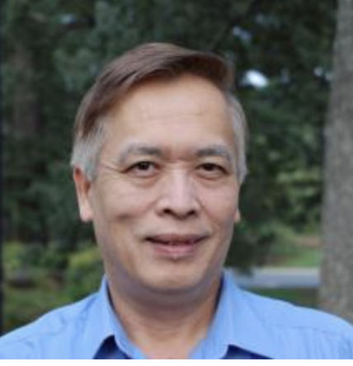
Formation evolution and chemical abundances of star-forming dwarf galaxies

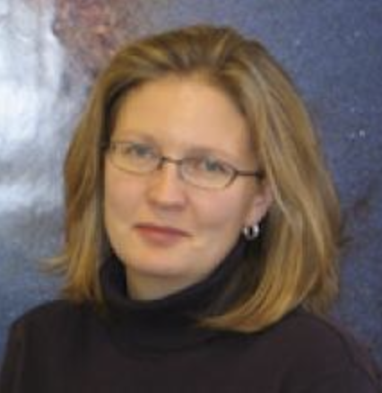

Kelsey Johnson

Professor, Department of Astronomy
Research Interests:
Star Formation, Interstellar medium

Sankaran Venkataraman

MasterCard Professor of Business Administration
Senior Associate Dean for Faculty and Research, Darden School of Business

AREAS OF EXPERTISE
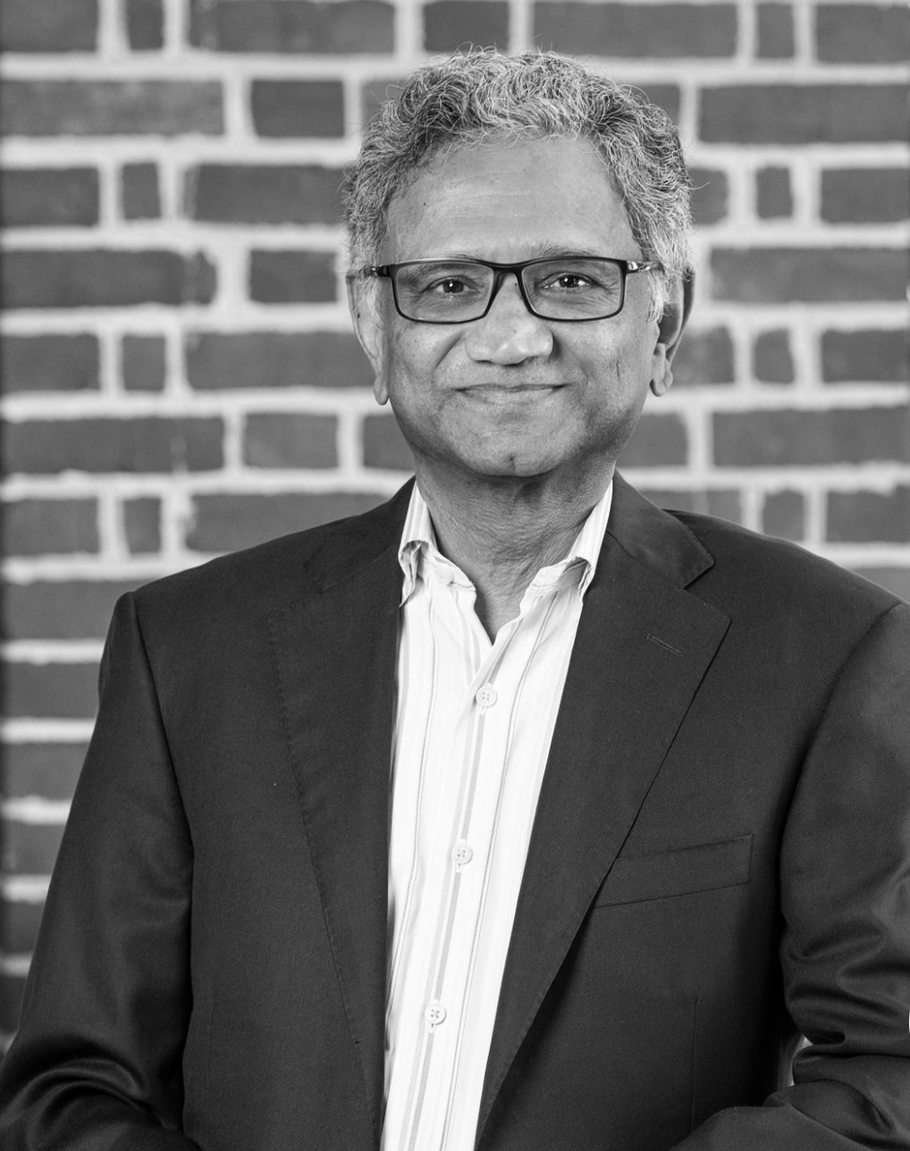
Entrepreneurial Opportunity, Business Strategy, Corporate Strategy, Corporate Venturing, New Venture Creation and Financing, Regional Development, Entrepreneurship Education, Managing Growth

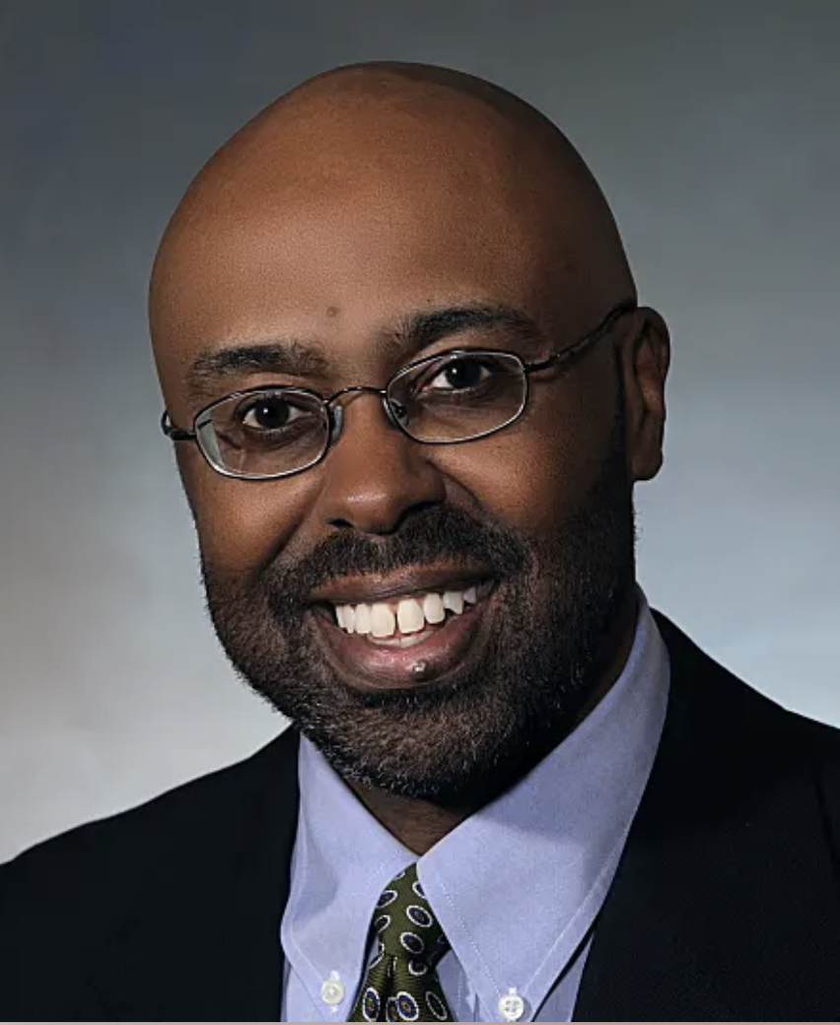

Ira C. Harris

Professor, McIntire School of Commerce

Director, M.S. in Commerce Program

Professor Harris teaches in the area of strategic management and strategic mergers & acquisitions. He was recognized as an All-University Teaching Award winner in 2020. Before joining the McIntire School, he taught for five years at the University of Notre Dame and was voted the 2001 Mendoza College of Business MBA Outstanding Professor of the Year. He also taught at Texas A&M University for three years. Professor Harris is a Certified Public Accountant in Illinois and Virginia.

NANA LAST

PROFESSOR, ARCHITECTURE

FACULTY

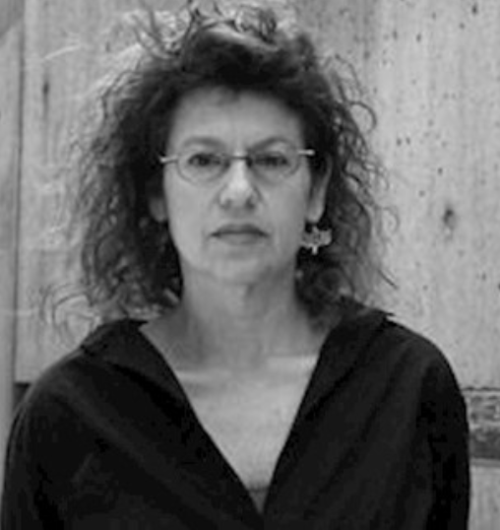
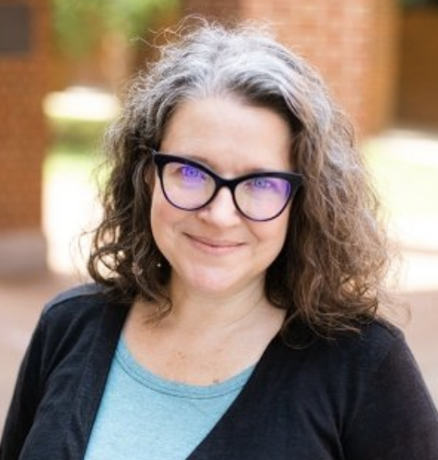
My scholarly work constructs theory-based intersections between architecture, art, science and culture in modern and contemporary society. At the center of this undertaking is the conviction that theory, by nature is interdisciplinary, and therefore is a preeminent tool in relating thinking from one realm into another. This has generated three main strains of my research: 1. intersections of architecture and philosophy, 2. research in conceptual art and architecture, and 3. intersections between narrative, technology and science. Current topics include architectural fluidity, cultural relations between architecture and Big Data and work on visualizing intellectual constructs in science and cultural theory.

Tisha Hayes

Professor of Education, Director, McGuffey Reading Center

Tisha Hayes has taught students with reading disabilities in the primary through middle grades as a special educator and reading specialist. She teaches courses on the diagnosis of and intervention for reading difficulties as well as English/Language Arts methods for elementary educators. She works with pre-service and in-service teachers at the McGuffey Reading Center, where students across the grades receive diagnostic and intervention services.

Hayes' interests have focused on the support of readers who struggle through university-based programs and partnerships. Her work has been published in Reading Research Quarterly, Literacy Research and Instruction, Communication Disorders Quarterly, Journal of Adult and Adolescent Literacy, and the Handbook of Reading Disability Research; she is co-author of Words Their Way with Struggling Readers, Grades 4-12, Vocabulary Their Way (2nd edition) and Developing Word Recognition.
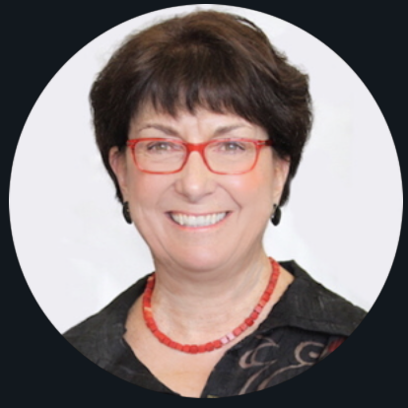

Sallie Keller

Professor of Data Science by Courtesy School of Data Science

Director of Social & Decision Analytics Division and Distinguished Professor Biocomplexity Institute

Professor School of Medicine

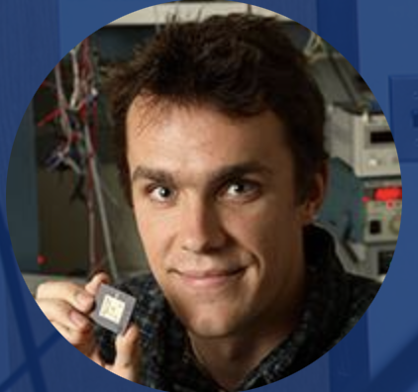
Sallie Ann Keller is a Professor of Data Science by Courtesy, an endowed Distinguished Professor in Biocomplexity, Director of the Social and Decision Analytics Division within the Biocomplexity Institute and Initiative at University of Virginia and Professor of Public Health Sciences. Her areas of expertise are social and decision informatics, statistical underpinnings of data science, and data access and confidentiality.

Benton H. Calhoun

Professor, Electrical and Computer Engineering

Benton H. Calhoun received his B.S. in Electrical Engineering with a concentration in Computer Science from the University of Virginia in Charlottesville, VA, in 2000. He received his M.S. and Ph.D. degrees in Electrical Engineering from the Massachusetts Institute of Technology in Cambridge, MA, in 2002 and 2006, respectively. Dr. Calhoun joined the faculty at the University of Virginia in 2006.

Research Interests
Internet of Things
Low Power Design
VLSI Design
Embedded Systems

Harsha K. Chelliah

Professor, School of Engineering
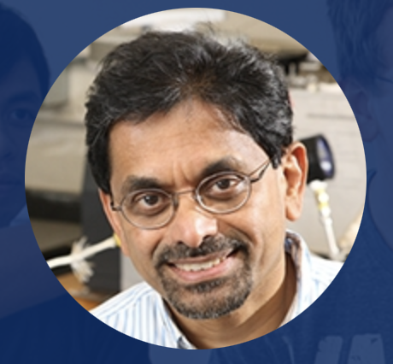
Fellow of American Society of Mechanical Engineers

Professor Chelliah joined the UNIVERSITY OF VIRGINIA in the Fall of 1992. He received his B.Sc. degree (First-Class Honors) in Mechanical Engineering from the University of Moratuwa in Sri Lanka in January 1981, MS degree in Mechanical Engineering from SUNY at Stony Brook in August 1984, and Ph.D. degree in Mechanical and Aerospace Engineering from Princeton University in January 1989. After completion of his Ph.D., he continued his research work at Princeton University as a Research Associate/Staff Member from 1988-1992.

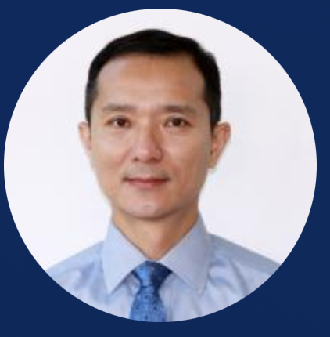
Professor Chelliah is an active member of the Combustion Institute, the American Institute of Aeronautics and Astronautics (AIAA), and the American Society of Mechanical Engineers (ASME). He is a Fellow of ASME, an Associate Fellow of AIAA and a member of the AIAA Technical Committee on Propellants and Combustion. He is also a member of the Editorial Board of the journal Combustion Theory and Modeling.

Haibo Dong
Professor, Aerospace Engineering
Director of Undergraduate Aerospace Engineering

Professor Dong joined UVA as an Associate Professor in August 2012. Prior to his position at UVA, Dr. Dong was an associate professor of Mechanical Engineering at the Wright State University. He obtained his Ph.D. degree in Aerospace Engineering from UCLA in 2003. After completing his doctorate, he spent three years as a post-doctoral researcher at the George Washington University on an Office of Naval Research (ONR)-sponsored MURI program.

Research Interests
Fluid Mechanics
Bio-inspired systems
Morphing structures/biomimetics

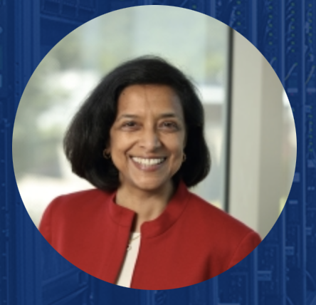

Sandhya Dwarkadas

Walter N. Munster Professor and Chair

Department of Computer Science

Research interests include:

Parallel and distributed computing, computer architecture, and the interaction and interface between the compiler, runtime/operating system, and underlying architecture.

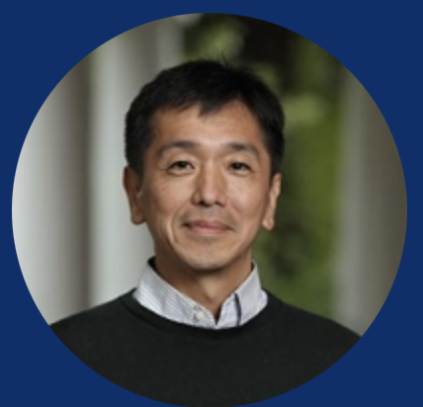
Her research lies at the intersection of computer hardware and software with a particular focus on support for parallelism. She has made fundamental contributions to the design and implementation of shared memory both in hardware and software, and to hardware and software energy- and resource-aware configurability.

Tomonari Furukawa

Professor and Zinn Faculty Scholar, School of Engineering

Director of VICTOR Lab

Professor Furukawa received his B.Eng. in Mechanical Engineering from Waseda University, Japan, in 1990, and a M.Eng. (Research) in Mechatronic Engineering from University of Sydney, Australia, in 1993 and a Ph.D in Quantum Engineering and Systems Science from University of Tokyo, Japan, in 1996. He has extensive research experiences in the field of robotics and computational mechanics. He has published over 300 journal and refereed conference papers, served on Editorial Boards for five international journals and as an international organizing committee member for over 10 international conferences and won a number of career research awards and paper awards.

Research Interests
Material characterization
Robotics and autonomous vehicles
Bayesian estimation and control
Computational and experimental mechanics
Multiphysics system analysis and design
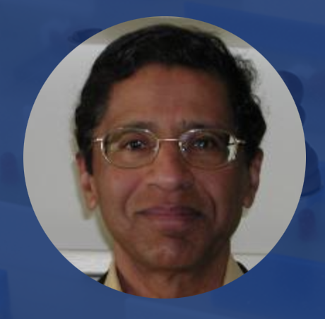
Automotive Safety

Mool C. Gupta

Langley Professor, Electrical and Computer Engineering

Professor Gupta is currently a Langley Distinguished Professor and Founding Director of NSF Industry/University Cooperative Research Center for Lasers and Plasmas at the University of Virginia. Previously, he was Director of the Applied Research Center, Program Director for Materials Science and Engineering and a Research Professor in the Department of Electrical & Computer Engineering at Old Dominion University. He has worked at the Research Laboratories of Eastman Kodak Company for 17 years as a Senior Scientist and Group Leader. Before joining Kodak, he was Senior Scientist at the Jet Propulsion Laboratory, California Institute of Technology, Pasadena, California. His educational experience includes: Senior Research Fellow at California Institute of Technology, Pasadena, Calif. (78-79), Postdoctoral Fellow at Cornell University, Ithaca, New York, (76-78) and Ph.D. in Physics from Washington State University, Pullman, Wash. (1973). Other professional activities includes: Materials Research Society Short Course Instructor for Optoelectronic Materials, Processes and devices course for over six years, Adjunct Professor, Department of Materials Science and Engineering, Cornell University for over eight years, Conference Chair for 1996 SPIE Conference on Nonlinear Frequency Conversion. He is Editor-in-Chief for CRC Handbook of Photonics first and second edition. He has over 150 research publications and 26 patents and was inducted in Kodak’s Inventors Gallery. He has taught courses at Cornell University, University of Rochester, MRS and SPIE meetings. His research interest includes Photon Processing of Materials, photovoltaics, nanomaterials and devices and sensors. He has been National Research Council Panel Chair for the development of NASA materials/nanomaterials technology roadmap and as a Principal investigator for NSF, DARPA, AFOSR, Navy, NASA DOE etc.

Research Interests
Intelligent Processing of Materials
Laser-materials interactions
Nanomaterials and nanomanufacturing
Solar Power
Battery/Fuel Cell Technologies/Energy Harvesting
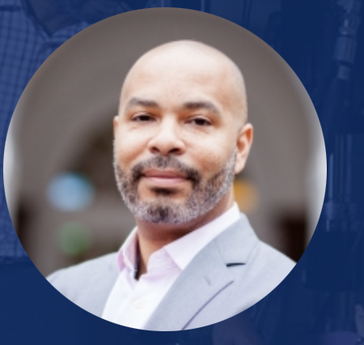

Devin K. Harris

Professor, School of Engineering and Chair, Department of Civil and Environmental Engineering

Director - Center for Transportation Studies

Professor Harris is chair of the Department of Civil and Environmental Engineering at the University of Virginia. He is also the Director of the CENTER FOR TRANSPORTATION STUDIES (CTS). His research and teaching interests focus on large scale infrastructure systems with a primary focus on condition monitoring and system performance. His research leverages image-based measurement techniques, simulation, visualization, and data analytics with applications in the areas of structural health monitoring, smart cities, and digital twins. Additional areas of focus include reinforced and prestressed concrete behavior, applications of innovative materials in civil infrastructure, and non-destructive evaluation. Dr. Harris’ research approach often utilizes a combination of laboratory and/or field investigations coupled with simulations.

Dr. Harris is an active member of in the American Concrete Institute (ACI), the Transportation Research Board (TRB), International Digital Image Correlation Society (IDICS), and the American Society of Engineering Education.

Allan Tsung, M.D., F.A.C.S.

S. Hurt Watts Professor
and Chair Department of Surgery, Medical School
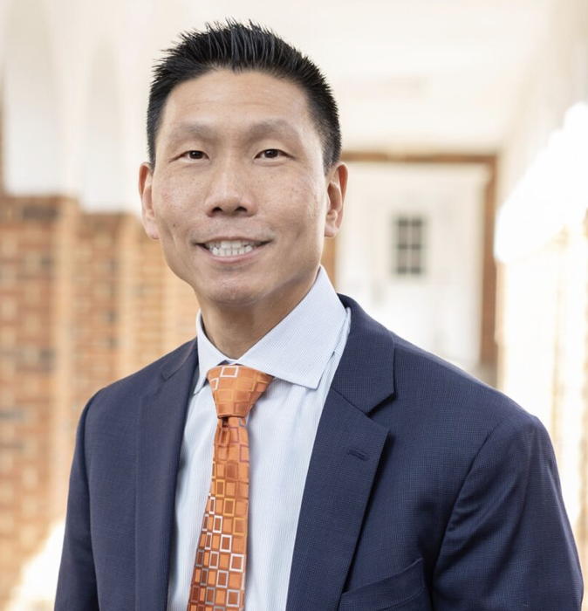
Allan Tsung, MD, is a surgical oncologist who specializes in evaluating and managing the care of patients with liver, bile duct, and pancreatic cancer.
An expert in laparoscopic and robotic surgery techniques, his goal is to provide innovative treatments, so patients recover faster than with traditional surgery. He also ensures each patient receives comprehensive and personalized care.

Expertise
Certification:
Amer Bd of Surgery (Surgery)
Clinical Practice:
Bile Duct Cancer, Liver Cancer, Pancreatic Cancer, Gastrointestinal Cancer, Stomach Cancer, Colon Cancer, Whipple Procedure, Gallbladder Cancer
Appointment:
Chair - Department of Surgery
Languages:
Chinese
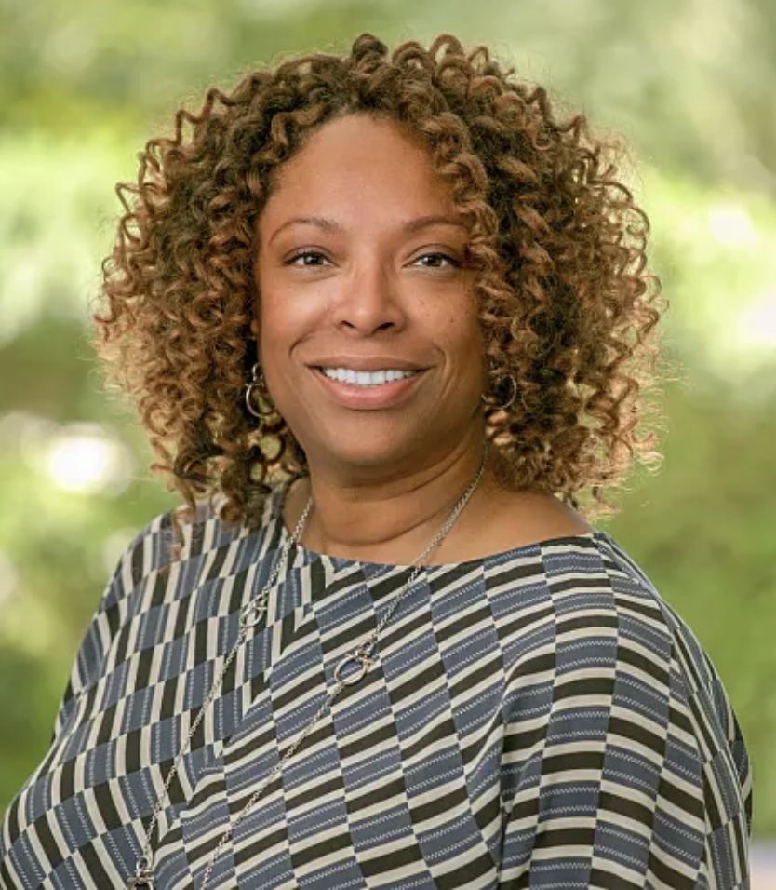

Nicole Thorne Jenkins

Dean, McIntyre School of Commerce

Nicole Thorne Jenkins is the John A. Griffin Dean of the McIntire School of Commerce at the University of Virginia. A Certified Public Accountant, Jenkins is an expert in financial reporting failures, share repurchases, and the effect of social networks on performance outcomes. As an award-winning educator, she has focused her instructional experience on financial reporting topics in both executive education and graduate and undergraduate programs. As a result of her ability to make both accounting and finance topics accessible, Jenkins is frequently called upon to instruct corporate professionals on related complex topics.
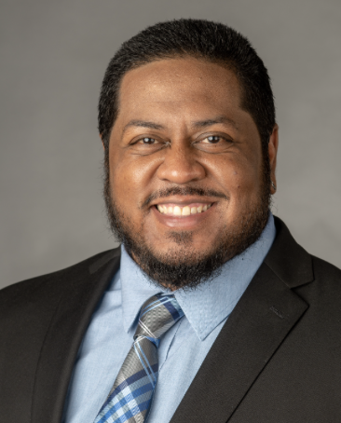

Sly Mata

Director of Diversity Education

Division for Diversity, Equity and Inclusion

Sly Mata (he, him, his) is the Director of Diversity Education, in the Office for Diversity, Equity, and Inclusion (ODEI). Sly directs a range of educational programming, the annual learning series, and custom workshops in partnership with University leaders and offices focused on educational development for staff, faculty and students. Sly also works with community leaders and a broad range of stakeholders to bring forward educational opportunities to advance the awareness and skills that support equity and inclusion.

Sly was born and raised in Phoenix, Arizona where he resided until 2009. A first-generation student, Sly is an Upward Bound Alum, Sly received his Bachelor’s degree in Interdisciplinary Studies from Arizona State University, a Masters in Public Service and Administration from Texas A&M and is currently a doctoral candidate at the College of Education at the University of Houston.

