Virginia State Police
Compensation, Compression, and Retention

October 2019

Superintendent

Executive Summary
Nationally, interest in law enforcement employment has fallen significantly in recent years, resulting in shrinking pools of applicants for local and state policing jobs. The Department of State Police is not immune from this trend and has endured significant vacancy rates and diminished applicant pools over the past five years. While there are many theories as to the cause of this crisis, the solutions are clear:
- Increase interest in the profession, which will in turn increase the number and quality of applicants for these critical jobs
- Create a transparent, sustainable compensation pathway to retain current employees
This pathway should be designed to protect the organization’s significant financial investments in recruiting, hiring, training, and retaining a high quality workforce.
The most effective way to generate interest in employment with the Virginia State Police is to adopt and fund a competitive and coherent compensation plan, like the one proposed herein. These types of compensation ladders provide a clear and consistent track for employee growth; similar efforts across the country have demonstrated great success. Research shows that the agency consistently loses our sworn employees to other agencies that pay more and have a compensation plan that guarantees financial advancement each year.
While the proposed compensation plan does have a significant one-time implementation cost, this expenditure must be evaluated against the cost of continually recruiting, training, and paying our troopers only to see them take their experience to other law enforcement agencies. When troopers leave our agency, the Commonwealth not only loses its financial investment, we also lose trained, seasoned personnel and replace them with inexperienced troopers who are prone to make mistakes in a profession where mistakes are not tolerated by the public.
This proposal is also intended to introduce fairness into a pay structure that has created pay compression among employees for many years. Currently, employees who move from position to position at the agent and sergeant level can end up at a much higher compensation level than their counterparts who promote to sergeant and stay in the same position, gaining experience in a challenging role.
If implemented, this compensation plan will attract significantly larger applicant pools, giving us the opportunity to hire better qualified troopers and then retain them; thus, capitalizing on the Commonwealth’s investment. Also, the initial adjustment will eliminate compression resulting in a fair compensation ladder that incentivizes a career with the State Police.
In the News:
In 2018, The Atlanta, Georgia Police Department (APD) was also suffering from the attrition and high vacancy rates associated with low pay. Once the problem reached a critical level the City Council took serious action—enacting comprehensive pay restructuring, which included up to 30% pay increases for their officers. Within a year the APD has reported significant returns on their investment, to include significantly improved retention rates and reduced vacancy rates. (https://www.ajc.com/news/crime--law/pay-raise-credited-for-big-spikes-apd-recruitment-retention/BFi5pwVb4W3peV67n8yCiO/)
The Chesterfield Observer reports that, “Patrol officer Will Jackson has spent more than half his life with the Chesterfield County Police Department . . . [and while] he’s in no rush to leave, . . . he was thinking about submitting his retirement papers this December, when he becomes eligible for a full Virginia Retirement System pension, until he learned about the Police Department’s new plan to retain its most experienced employees. . . The initiative, which Police Chief Col. Jeffrey Katz presented to the Board of Supervisors during a budget work session last Wednesday, would provide significant salary increases for the Police Department’s longest-serving employees as an incentive to delay retirement at a time when the department is struggling to staff all of its patrol beats.” (https://www.chesterfieldobserver.com/articles/to-bolster-dwindling-ranks-police-department-proposes-salary-increases-for-longtime-officers/)
The U.S. Department of Justice Office of Community Oriented Policing Services publication ‘Guidelines for Starting and Operating a New Police Department’ nots that agencies should, “Be aware that your competitors for good officers are the big, higher paying agencies in your area. If you are not prepared to pay a good wage, do not expect to be able to hire qualified applicants.” The report also notes that; “Officer retention should be a concern from the outset . . . A great deal of time and money is needed to train and certify each new officer and orient him or her to the community. . . Keeping turnover to a minimum represents a significant cost savings to the department. (https://cops.usdoj.gov/RIC/Publications/cops-p109-pub.pdf)
The International Association of Chiefs of Police Best Practices Guide for Recruitment, Retention, and Turnover of Law Enforcement Personnel states that: “Over time, agencies with higher turnover and less experienced officers will suffer a reduction in productivity and lower quality of service delivery.
Unfortunately for the agency, the first persons to leave are often the best employees simply because they have better skills and abilities to offer new employers.”https://www.theiacp.org/sites/default/files/2018-08/BP-RecruitmentRetentionandTurnover.pdf
Recruitment
A primary agency concern addressed by this plan is recruitment of qualified new troopers. At the end of July 2019, there were 231 sworn vacancies. There are currently only 41 trainees in the 131st Basic Session preparing to fill these vacancies. As such, 190 vacancies remain, and will continue to grow with employees choosing other employment. Furthermore, the agency anticipates a mass retirement in 2020, when 315 sworn employees are eligible for retirement at the three-year anniversary of the last sworn salary adjustment of $6,793 (2017).
Overall, compared to the advertised entry level salaries of other state police/highway patrol departments, Virginia’s entry level salary is below the national average of $50,759.31.

When compared to other Virginia departments, the State Police entry level salaries fall within the middle of the pack in both the Richmond/Hampton Roads market and the Northern Virginia market. This status is in large part due to the raise in 2017, which targeted the starting salary, but did not include a funded pay ladder that addressed retention and compression. This new plan proposes to rectify this by addressing all three essential components of a comprehensive compensation plan: starting salary, pay compression, and retention.

At this time, the agency’s compensation is based on the fluidity of the Commonwealth’s budget which is itself based upon the health of the economy, competing political plans, and competition from other agencies for scarce general funds. Therefore, we are unable to provide the stability that new recruits seek; and they therefore, choose other agencies with more consistent and predictable compensation plans.
A significant advantage of the agency’s proposal is that it provides a clear picture for new or potential recruits of what they can expect to make over the course of their career. Other agencies, for instance Kentucky State Police, have the ability to provide detailed schedules of how years of service will impact an employee’s compensation—VSP currently cannot provide this level of transparency.
Diversity
The Department of State Police is committed to hiring a diverse workforce. Providing a competitive salary and benefits package will contribute to this effort, as part of an overall push to increase the appeal of our agency. As cited in ‘Law Enforcement Diversity: Best Practices for Recruiting Minority and Women Candidates:’ “In today’s world, a qualified minority or woman candidate may potentially be involved in multiple hiring processes simultaneously and be quickly hired by the most aggressive department, or the one that the candidate finds most attractive. Therefore, police departments should assess how appealing their agency is when compared to others, and offer incentives to stand out and attract the most qualified diverse candidates.”
Retention
Between Aug 1, 2018 and July 31, 2019, 9 troopers left primarily for a better job, with 39 others leaving for various reasons to include other employment. 32 troopers left during probation.
- The total cost to onboard and train these 80 employees was $2,757,280.
- The salary costs expended before these employees left were $13,256,472.
- Therefore, the total loss of investment in these employees was $16,013,752 (not including the cost of any specialized training these employees may have received)
It is important to note that the $16 million dollars lost from the 80 employees leaving the agency is a significant gain for other agencies, as they benefit from employing fully trained, certified law enforcement officers at the expense of the Commonwealth. Furthermore, this large financial loss does not take into consideration the costs associated with the significant experience that is also lost to other agencies. As these tenured employees leave VSP, the agency is left with no option except to start over with the recruiting process, which ultimately replaces the years of training and experience with a brand new inexperienced entry level trooper—this is much like harvesting a mature forest and replanting it with vulnerable seedlings.
Providing transparency through a more competitive salary structure, while simultaneously eliminating compression, will greatly reduce the number of employees leaving the agency for other opportunities; thereby, protecting the Commonwealth’s investment.

Pay Compression
In addition to addressing overall compensation through an established and funded pay ladder, this proposal eliminates pay compression issues that have in large part been caused by varying promotional pathways. Differing pathways allow employees with similar experience levels to arrive at the same rank with large discrepancies in pay, as reflected in the chart below.

Trooper A | Trooper B | Trooper C | Trooper D
Makes Senior Trooper and receives a 10% raise | Makes Senior Trooper and receives a 10% raise | Makes Senior Trooper and receives a 10% raise | Promotes to Sergeant and receives a 10% raise
Promotes to Special Agent and receives a 10% raise | Makes Master Trooper and receives a 10% raise | Promotes to Sergeant and receives a 10% raise | Promotes to First Sergeant and receives a 10% raise
Promotes to Sergeant and receives a 10% raise | Promotes to Special Agent and receives a 10% raise | Promotes to First Sergeant and receives a 10% raise
Promotes to First Sergeant and receives a 10% raise | Promotes to Sergeant and receives a 10% raise
 | Promotes to First Sergeant and receives a 10% raise
First Sergeant | First Sergeant | First Sergeant | First Sergeant
40% above initial assignment | 50% above initial assignment | 30% above initial assignment | 20% above initial assignment

This dynamic is further compounded by sporadic percentage increases that impact the entire workforce. For example, a 5% increase applied to an employee making 30% more than his/her counterpart at the same rank exacerbates the compression problem.
 | Base Salary | 5% Increase | Total New Salary
Trooper D | $35,000 | $1,750 | $36,750
Trooper B | $50,000 | $2,500 | $52,250
Difference | $15,000 |  | $15,500

In the above example, the initial compression gap of $15,000 for two employees at the same rank grew to $15,500. While the increase allowed both employees to benefit from a raise, the widening gap between employees of the same rank is unfair and devastating to morale. This dynamic only grows over an employee’s career when well-intentioned but sporadic percentage raises are the only type of pay increase.
As explained in the graphics below, to address the pay compression issue, the attached compensation proposal ties salary increase to years of experience rather than to changes in position.
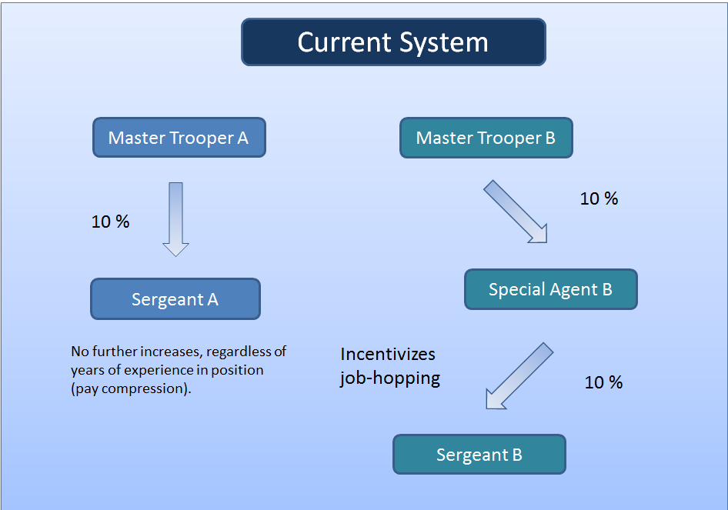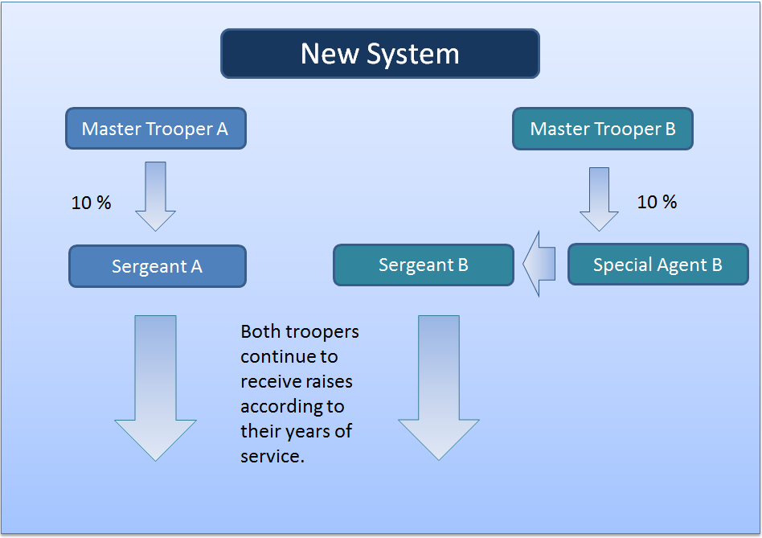
All sworn employees will continue to have the same variety of promotional opportunities, but those who choose to stay in a position and gain knowledge and experience with a specialty or a community will not find themselves punished for this.
Analysis of the current pay structure revealed that VSP salaries tend to cluster at the bottom of the respective salary ranges, regardless of the average years of experience for that range. It is hoped that the proposed restructuring will eliminate this type of pay stagnation.

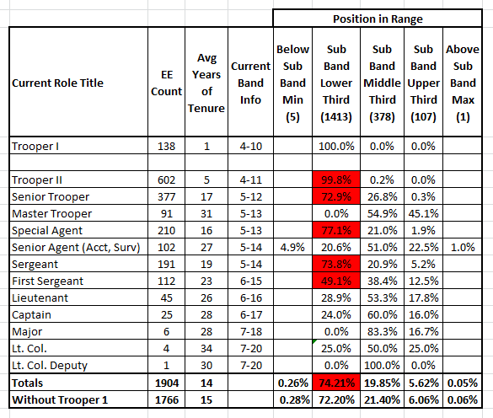

The proposal is further designed so that all sworn employees would receive a 1.5% annual increase, with a 5% retention adjustment at each 5 year benchmark. These periodic adjustments become a retention incentive applying to all sworn personnel, and provide a true understanding of an employee’s full compensation forecast. Such a compensation plan affords employees hope and a reason to remain with the agency. Employees must have measured growth opportunities in order to protect the Commonwealth’s significant investment in its State Police. Absent a comprehensive funded pay plan, the Commonwealth will continue to lose its highly trained and skilled Troopers to other modern competitive police organizations.

Costs of Proposed Plan

To address salary stagnation and the other issues described in this document, the proposed schedule causes salary levels to be based on role title, sub band, and number of VSP sworn service years. The schedule begins at year one with the sub band minimum and ends at 30 years with the sub band maximum. Employee total years of VSP sworn service are rounded down and include interrupted service.
This plan would replace other forms of sworn base pay increases that agency employees may be eligible to receive from year to year. Special rates (e.g. for surveillance teams) would no longer apply, as a further anti-compression measure. Once a sworn employee reaches sub band maximum at 30 years, future compensation increases would only be awarded with increases that impact all state employees.
Costs to implement the new schedule would be highest in the first year, with a decrease in subsequent years. The costs are partially offset by improved employee retention, with fewer Commonwealth dollars lost to other agencies. After implementation, ongoing annual costs will vary year to year as employees or groups of employees reach various milestones or as employees enter or leave the sworn population, etc.

Based on the July 31, 2019 base salary figures and current years of sworn service, the initial projected cost to move sworn employees into fair and meaningful pay levels within the proposed schedule is $18.98 million. This includes necessary adjustments for senior troopers and special agents. In addition to the $18.98 million for salaries, benefits will add an additional $6.76 million, for a projected initial implementation cost totaling $25.7 million.

Year | Salary (millions) | Benefits (millions) | Total
First | $18.98 | $6.76 | $25.7
Second | $2.7 | $1 | $3.7
Third | $2.6 | #.93 | $3.5

Conclusion
Fair compensation is essential to recruiting and retaining qualified troopers in today’s challenging times. As expressed by NBC news:
Numerous police departments around the country are desperately losing manpower with decreasing numbers of officers and recruits. Law enforcement is becoming less of a desirable career choice due to diminishing pay, high risk, and of course a recent bad rap — a trend that could put public safety at risk, say policing experts.
https://www.nbcnews.com/news/us-news/police-shortage-hits-cities-small-towns-across-country-n734721
This agency has no alternative but to appeal to the General Assembly and the Governor’s Office for a long term, sustainable solution to attract and retain the most qualified troopers to serve the Commonwealth. This effort is not intended to insinuate that the agency is not appreciative of past pay increases; rather, we hope to inform and educate decision-makers of the gravity and long-term consequences associated with this critical problem. If left unaddressed, we will not be successful in recruiting sufficient numbers of employees to fill our growing number of vacancies across the Commonwealth or retain the employees we already have. Consequently, we will fail to meet the service demands of the agency.

It is our assertion the Virginia Department of State Police is one of the finest law enforcement agencies in the nation; however, the current recruitment and retention concerns impair our ability to maintain this well-earned reputation. Recruitment, retention, and compression problems will eventually clash with an expanding mission and higher demands for service. The Department of State Police needs to increase interest in the profession, which will increase the number of qualified and diverse applicants for these critical jobs, and provide current employees a sustainable compensation pathway. If funded, the proposed compensation plan will protect the Commonwealth’s significant financial investments by improving recruiting, hiring, training, and retaining a high quality workforce.

Retirement income is determined by a trooper’s three highest paid years.
https://pdfs.semanticscholar.org/bb5e/38d85528d1924d3efbdd90f85e9936f0df10.pdf

